Historische Karten 1 – M
Quelle: Bildarchiv der deutschen Kolonialgesellschaft in der Universitätsbibliothek Frankfurt / Bildnummer: 042-0245-01
- Beschreibe die Karte.
______________________________________________________________________________________________________________________________________________________________________________________________________________________________________________________________________________________________________________________________________________________________________________________________________________________________________________________________________________________________________________________________

2. Suche in deinem Atlas eine ähnliche Karte.
Vergleiche nun beide Karten. Was entdeckst du? Was fehlt auf der obigen Karte?
______________________________________________________________________________________________________________________________________________________________________________________________________________________________________________________________________________________________________________________________________________________________________________________________________________________________________________________________________________________________________________________________

3. Gib eine Karte in Auftrag, die das deutsche Kolonialreich zeigt.
Begründe, welche Aspekte besonders wichtig sind.
______________________________________________________________________________________________________________________________________________________________________________________________________________________________________________________________________________________________________________________________________________________________________________________________________________________________________________________________________________________________________________________________

4. Welcher Eindruck entsteht bei der deutschen Bevölkerung, wenn die Karte in der Tageszeitung abgedruckt wird?
___________________________________________________________________________________________________________________________________________________________________________________________________________________________________________________________________________________________________________________________________________________________________________________________________________________________________________________________________________________________________________________________________________________________________________________________________________________

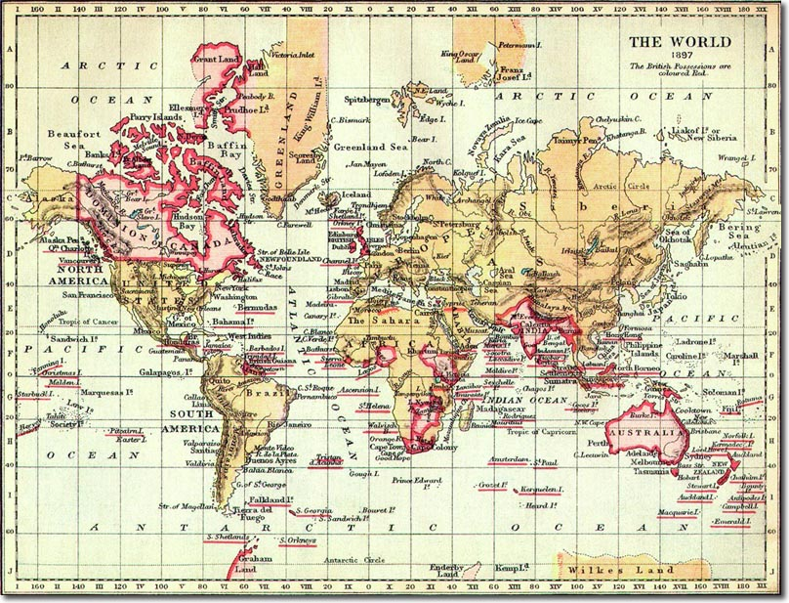
Historische Karten 2 - M
Quelle: Wikimedia Commons / https://en.wikipedia.org/wiki/File:British_Empire_1897.jpg
- Beschreibe die Karte.
______________________________________________________________________________________________________________________________________________________________________________________________________________________________________________________________________________________________________________________________________________________________________________________________________________________________________________________________________________________________________________________________

2. Suche in deinem Atlas eine ähnliche Karte.
Vergleiche nun beide Karten. Was entdeckst du? Was fehlt auf der obigen Karte?
______________________________________________________________________________________________________________________________________________________________________________________________________________________________________________________________________________________________________________________________________________________________________________________________________________________________________________________________________________________________________________________________

3. Gib eine Karte in Auftrag, die das britische Kolonialreich zeigt.
Begründe, welche Aspekte besonders wichtig sind.
______________________________________________________________________________________________________________________________________________________________________________________________________________________________________________________________________________________________________________________________________________________________________________________________________________________________________________________________________________________________________________________________

4. Welcher Eindruck entsteht bei der britischen Bevölkerung, wenn die Karte in der Tageszeitung abgedruckt wird?
___________________________________________________________________________________________________________________________________________________________________________________________________________________________________________________________________________________________________________________________________________________________________________________________________________________________________________________________________________________________________________________________________________________________________________________________________________________

